Final Project: Animal Shelter Data Analysis

INFSCI 2710 Database Management

Instructor- Prof. Philip Cwynar

School of Computing & Information, University of Pittsburgh

Team Members:

Yue Xing (Yux28)

Ben Ying (Bey8)

Andy Zhao (Daz55)

Table of Contents

1. Create Schema

1.1 ER diagram

1.2 Sample codes for tables

1.3 Data dictionary

2. Basic data

3. Intercrossing analysis

3.1 Breed

3.2 Size

3.3 Color

3.4 Age

3.5 Sex

3.6 Time

3.7 Name

4. Prediction

5. Other novel discoveries

5.1 Business hour

5.2 Work peaks

5.3 Birthday

5.4 Shelter capacity

5.5 Main color

6. References

**1.Create Schema**

**1.1 ER diagram**

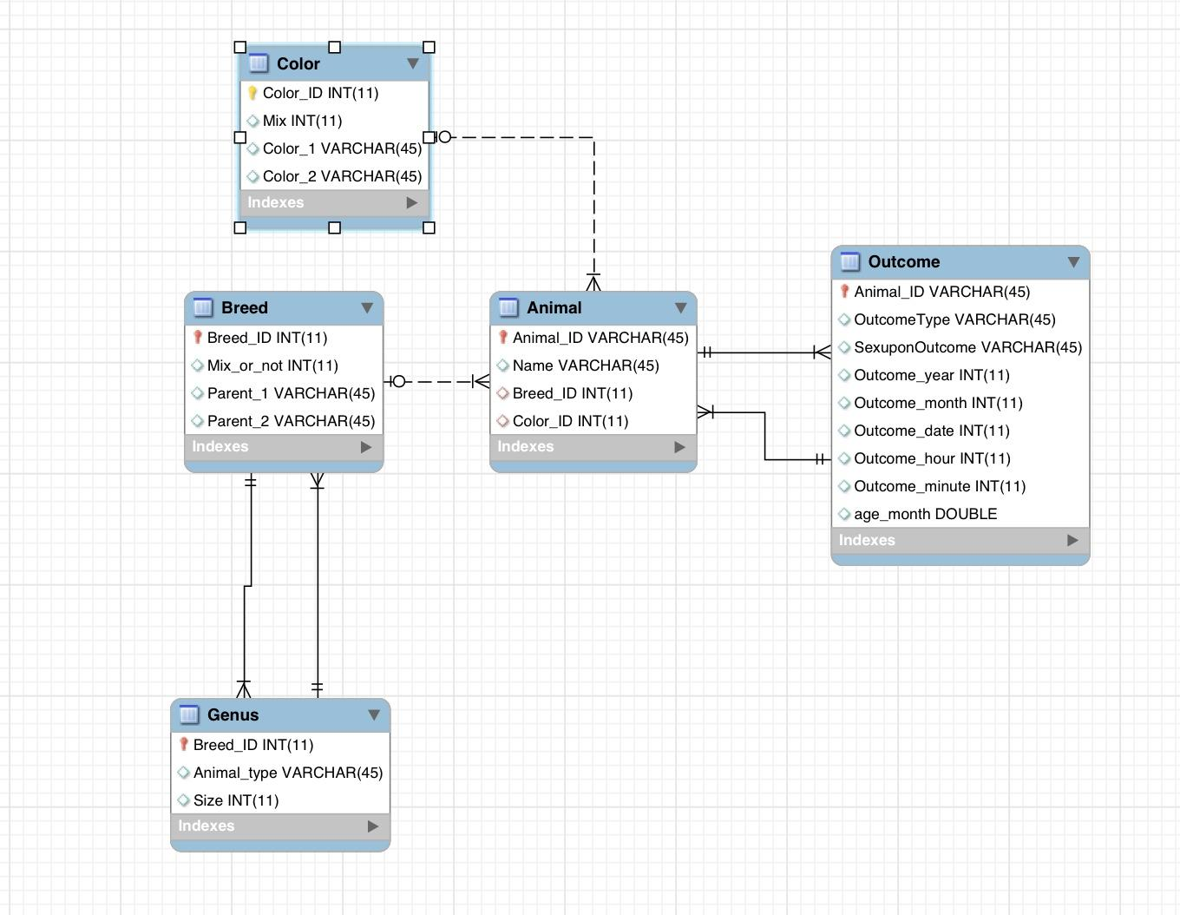

**1.2 Sample codes for tables**

**(1)  sample codes for creating tables and contraints**

sql_create ='''

       CREATE TABLE Outcome (

       `Animal_ID` varchar(64) NOT NULL,

       `OutcomeType`  varchar(64),

       `SexuponOutcome`  varchar(64),

       `Outcome_year`  int(16),

       `Outcome_month`  int(16),

       `Outcome_date`  int(16),

       `Outcome_hour`  int(16),

       `Outcome_minute`  int(16),

       `age_month`  double(32,2),

        PRIMARY KEY (`Animal_ID`)

         )

'''

'''

ALTER TABLE `animal_shelter`.`Outcome`

ADD CONSTRAINT o2a

FOREIGN KEY (Animal_ID)

REFERENCES Animal(Animal_ID);

'''

cursor.execute(sql_create)

**(2) sample codes for loading data**

for row in csv_data:

   if rowcount > 0:

       try:

           cursor.execute('INSERT INTO Outcome(`Animal_ID`,`OutcomeType`,`SexuponOutcome`,`Outcome_year`,`Outcome_month`,`Outcome_date`,`Outcome_hour`,`Outcome_minute`,`age_month`)VALUES(%s,%s,%s,%s,%s,%s,%s,%s,%s)',row)

       except:

           cursor.execute('INSERT INTO Outcome(`Animal_ID`,`OutcomeType`,`SexuponOutcome`,`Outcome_year`,`Outcome_month`,`Outcome_date`,`Outcome_hour`,`Outcome_minute`)VALUES(%s,%s,%s,%s,%s,%s,%s,%s)',(row[0],row[1],row[2],row[3],row[4],row[5],row[6],row[7]))

   rowcount += 1

mydb.commit()

cursor.close()

print "Done"

**(3) sample codes for spliting the raw data**

num=[]

term=[]

for content in f_csv:

  try:

      m = re.match(r'(\d+) (\D+)', content[5])

      if 'day' in m.group(2):

          num.append(int(m.group(1))/30.0)

          term.append(m.group(2))

      elif 'week' in m.group(2):

          num.append(int(m.group(1))/4.0)

          term.append(m.group(2))

      elif 'year' in m.group(2):

          num.append(int(m.group(1))*12.0)

          term.append(m.group(2))

      else:

          num.append(m.group(1))

          term.append(m.group(2))

  except:

      num.append(' ')

      term.append(' ')

age={'age_month':num,'age_term':term}

a=DataFrame(age)

a.to_csv(path_d)

**1.3 Data dictionary**

|  |  |  |  |  |  |  |
| --- | --- | --- | --- | --- | --- | --- |
| Table | Var Name | Variable Description | Data Type | Width | Nullable | Values |
| Animal,Outcome | Animal_ID | animal's ID | Varchar | 64 | No |  |
| Outcome | OutcomeType | outcome type | Varchar | 64 | Yes |  |
| Outcome | Outcome_year | the year of outcome | Int | 16 | Yes |  |
| Outcome | Outcome_month | the month of outcome | Int | 16 | Yes |  |
| Outcome | Outcome_date | the date of outcome | Int | 16 | Yes |  |
| Outcome | Outcome_hour | the hour of outcome | Int | 16 | Yes |  |
| Outcome | Outcome_minute | the min of outcome | Int | 16 | Yes |  |
| Outcome | Animal_type | cat or dog | Varchar | 64 | Yes |  |
| Animal | Name | name | Varchar | 64 | Yes |  |
| Animal,Breed,Genus | Breed_ID | breed's ID | Int | 16 | No |  |
| Outcome | age_month | animal's age in month | Double | 32,2 | Yes |  |
| Breed | Breed_Mix | breed's mix mark | Int | 16 | No | 0=Pure  1=Mix  2=Crossbreed |
| Breed | Parent_1,Parent_2 | animal's parent breed | Varchar | 64 | Yes |  |
| Animal,Color | Color_ID | color's ID | Int | 16 | No |  |
| Color | Color_1, Color_2 | animal's color | Varchar | 64 | Yes |  |
| Color | Color_Mix | color's mix mark | Int | 16 | No | 1=one color; 2=two colors; 3= tricolor |
| Genus | Size | animal's size | Int | 16 | Yes | 1=small; 2=medium; 3=big |
| Outcome | SexuponOutcome | Sex condition | Varchar | 64 | Yes |  |

**2. Basic data**

**2.1 Quantity of cats and dogs**

select count(*),Animal_type from Final group by Animal_type;

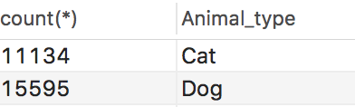

**2.2 Majority of breed**

select count(*) 'sum',Breed_mix,Parent_1,Parent_2,Animal_type from Final

group by Breed_mix,Parent_1,Parent_2,Animal_type order by count(*) desc;

-- cat

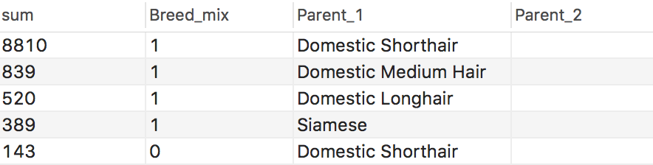

-- dog

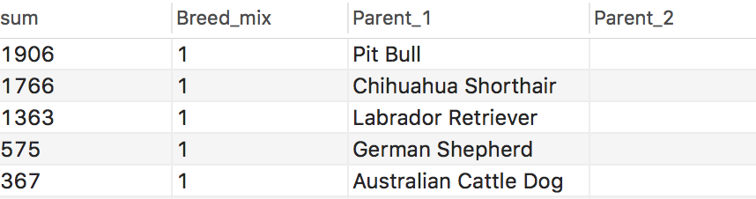

**2.3 Size distribution**

select count(*) 'sum', size,Animal_type from Final group by size,Animal_type;

-- cat

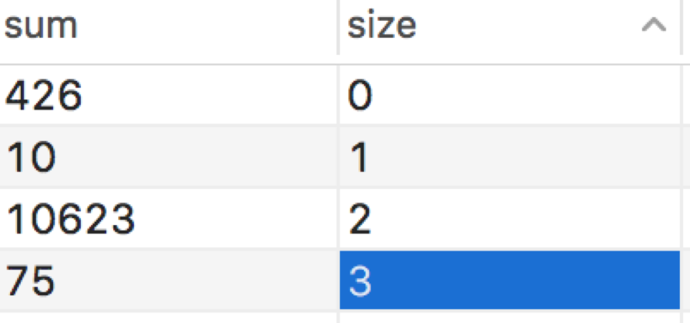

-- dog

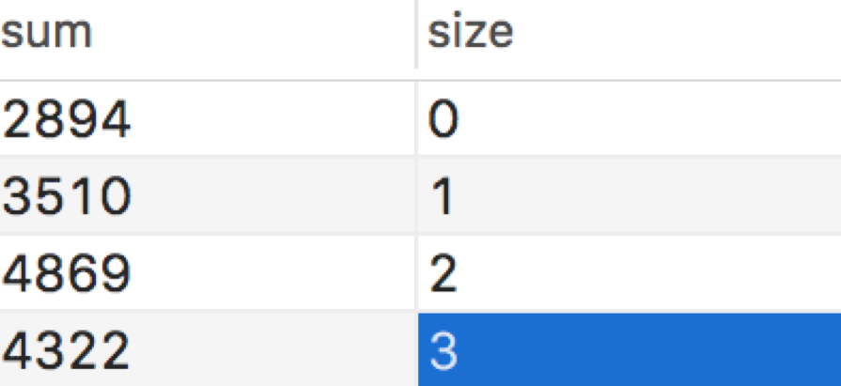

**2.4 Majority of color**

select count(*) 'sum',Color_mix,Color_1,Color_2 from Final where Animal_type = "Cat"

group by Color_mix,Color_1,Color_2 order by count(*) desc;

-- cat

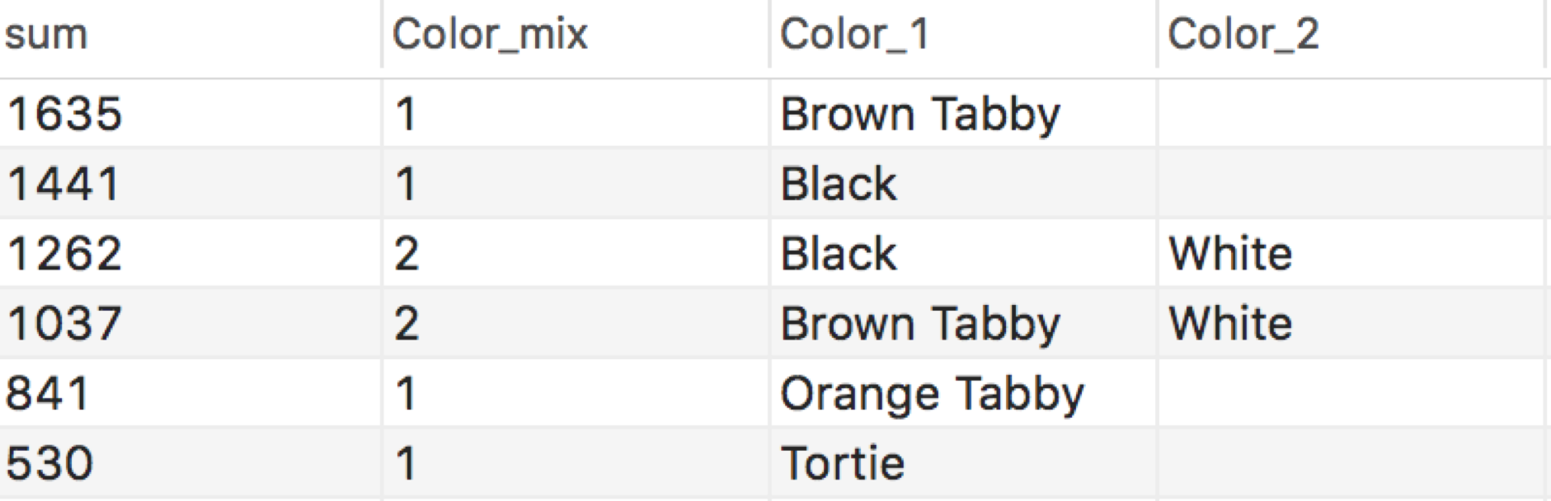

select count(*) 'sum',Color_mix,Color_1,Color_2 from Final where Animal_type = "Dog"

group by Color_mix,Color_1,Color_2 order by count(*) desc;

-- dog

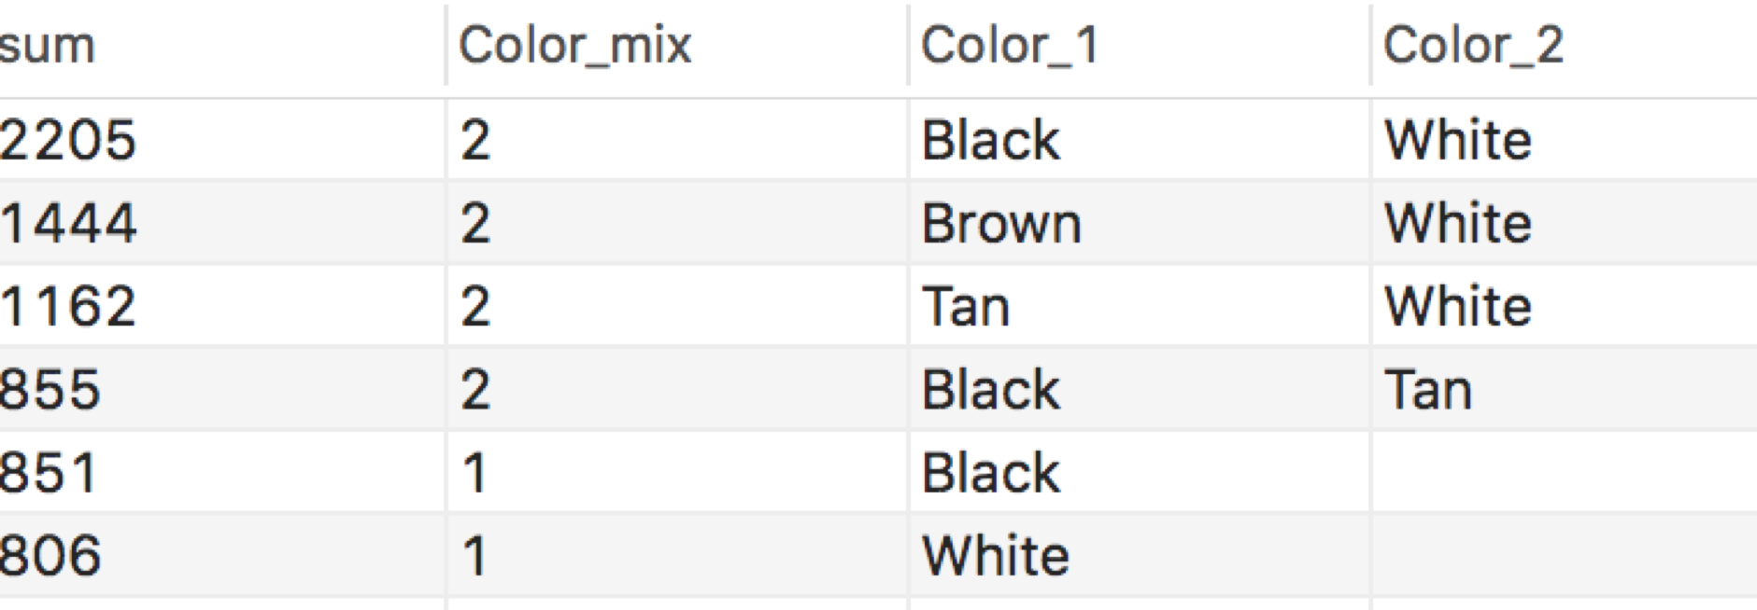

**2.5 Age distribution**

** 0-2 months: suckling period

2-12 months: sexual maturity

12-60 months: grown up

60-120 months: moon of life

120+ months: old age

select count(*) 'sum', age_month from Final where Animal_type="Dog"

group by age_month order by age_month;

select count(*) 'sum', age_month from Final where Animal_type="Cat"

group by age_month order by age_month;

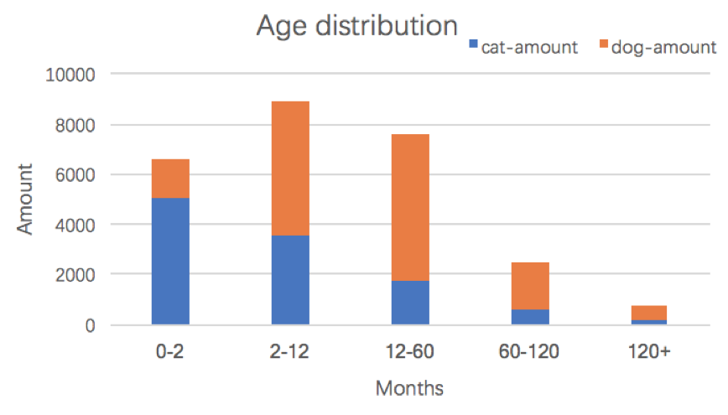

**2.6 Sex distribution**

select count(*),Animal_Type,SexuponOutcome from Final

group by Animal_Type,SexuponOutcome;

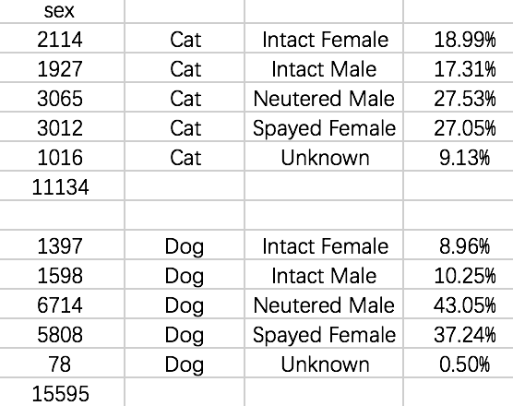

**2.7 Outcome distribution**

select count(*) 'sum',OutcomeType from Final group by OutcomeType order by count(*) desc;

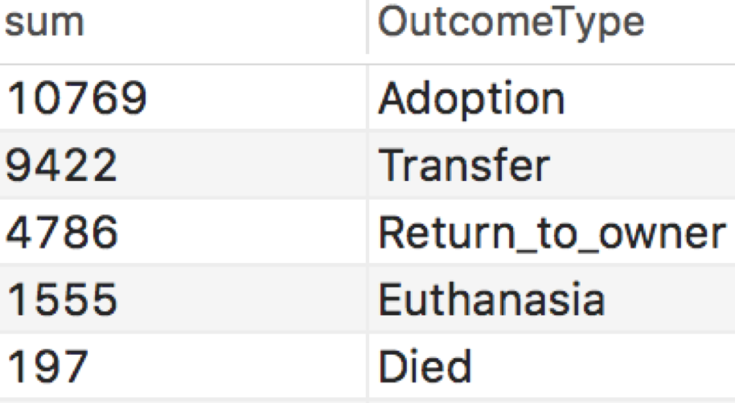

select Outcome_Type, count(Animal_Type) as cat_number from Final where Animal_Type = 'Cat' group by Outcome_Type;

select Outcome_Type, count(Animal_Type) as dog_number from Final where Animal_Type = 'Dog' group by Outcome_Type;

**different outcome type probablility

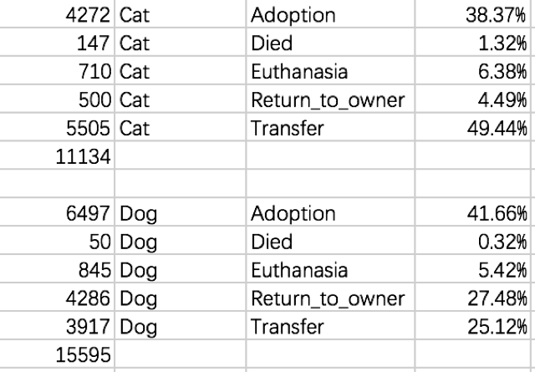

** outcome histogram

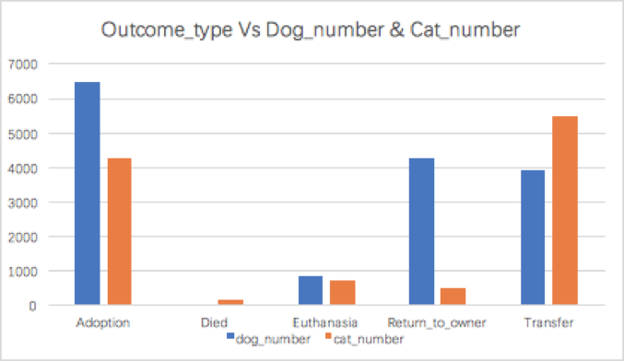

**3. Intercrossing analysis**

**3.1 Breed**

main code (filter data count more than 50, some works are in Excel):

create view temp7 as (select count(Animal_ID) as outcount,Breed_ID,OutcomeType from Shelter group by Breed_ID,OutcomeType);

create view temp6 as (select temp7.*, nametable.breed_name from temp7,nametable where temp7.Breed_ID=nametable.Breed_ID);

create view temp8 as (select temp6.*, breedpro.amount,breedpro.Animal_type from temp6,breedpro where temp6.Breed_ID=breedpro.Breed_ID);

**3.1.1 Adopted breed top10**

|  |  |  |
| --- | --- | --- |
| Black Mouth Cur | Dog | 60.32% |
| Queensland Heeler | Dog | 58.82% |
| Australian Kelpie | Dog | 56.84% |
| German Shepherd Labrador Retriever | Dog | 55.83% |
| Dachshund Chihuahua Shorthair | Dog | 55.07% |
| Cairn Terrier | Dog | 54.90% |
| Chihuahua Shorthair Dachshund | Dog | 53.06% |
| Catahoula | Dog | 50.96% |
| Snowshoe | Cat | 50.67% |

(Here is a bias: some really valuable and popular breeds may have less possibility to live in this shelter.)

**3.1.2 Transfered breed top10**

|  |  |  |
| --- | --- | --- |
| Shih Tzu | Dog | 60.38% |
| Domestic Shorthair Mix | Cat | 51.51% |
| Shih Tzu Mix | Dog | 51.00% |
| Domestic Medium Hair | Cat | 45.65% |
| Domestic Shorthair | Cat | 44.76% |
| Plott Hound | Dog | 43.84% |
| Snowshoe | Cat | 41.33% |
| Siamese | Cat | 39.59% |
| Domestic Longhair | Cat | 39.42% |
| Pointer | Dog | 33.33% |

**3.1.3 Death rate top10**

|  |  |  |
| --- | --- | --- |
| Domestic Longhair | Cat | 2.31% |
| Domestic Shorthair | Cat | 2.10% |
| Miniature Pinscher | Dog | 1.45% |
| Chihuahua Longhair Mix | Dog | 1.41% |
| Snowshoe | Cat | 1.33% |
| Anatol Shepherd | Dog | 1.32% |
| Domestic Medium Hair | Cat | 1.31% |
| Siamese | Cat | 1.29% |
| Domestic Shorthair Mix | Cat | 1.27% |
| Great Pyrenees | Dog | 1.16% |

**3.1.4 Euthanasia rate top10**

|  |  |  |
| --- | --- | --- |
| Chow Chow | Dog | 21.05% |
| Pit Bull | Dog | 13.64% |
| Pit Bull Mix | Dog | 13.48% |
| Labrador Retriever Pit Bull | Dog | 11.11% |
| German Shepherd Labrador Retriever | Dog | 10.94% |
| Domestic Longhair | Cat | 10.77% |
| Staffordshire | Dog | 10.64% |
| Rottweiler | Dog | 10.62% |
| American Bulldog | Dog | 10.09% |
| American Staffordshire Terrier | Dog | 9.78% |

**3.1.5 Return to Owner top10**

|  |  |  |
| --- | --- | --- |
| Golden Retriever | Dog | 46.97% |
| Rottweiler | Dog | 46.90% |
| Labrador Retriever | Dog | 44.93% |
| German Shepherd | Dog | 42.86% |
| Siberian Husky | Dog | 42.75% |
| Shih Tzu | Dog | 38.00% |
| Beagle | Dog | 37.10% |
| Yorkshire Terrier | Dog | 37.06% |
| Chow Chow | Dog | 36.84% |
| Miniature Schnauzer | Dog | 36.76% |

**3.1.6 breed mix or not and outcome**

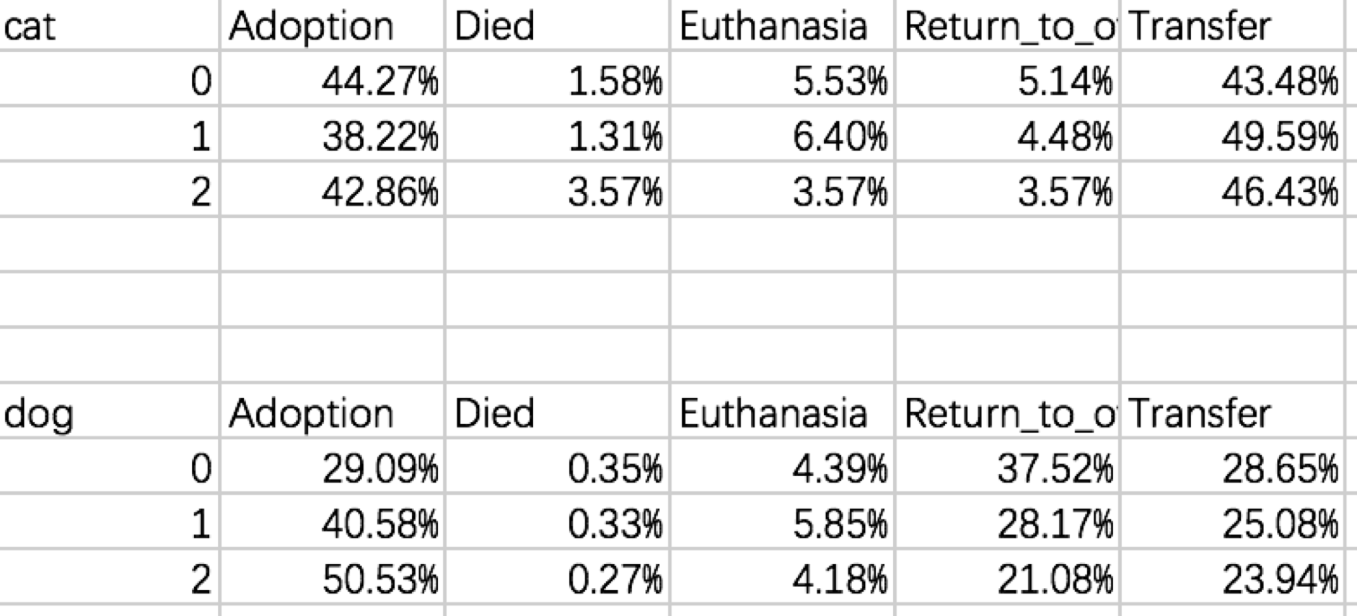

**3.2 Size[1][2]**

select count(*),OutcomeType,size,Animal_Type from Final

group by OutcomeType,size,Animal_Type;

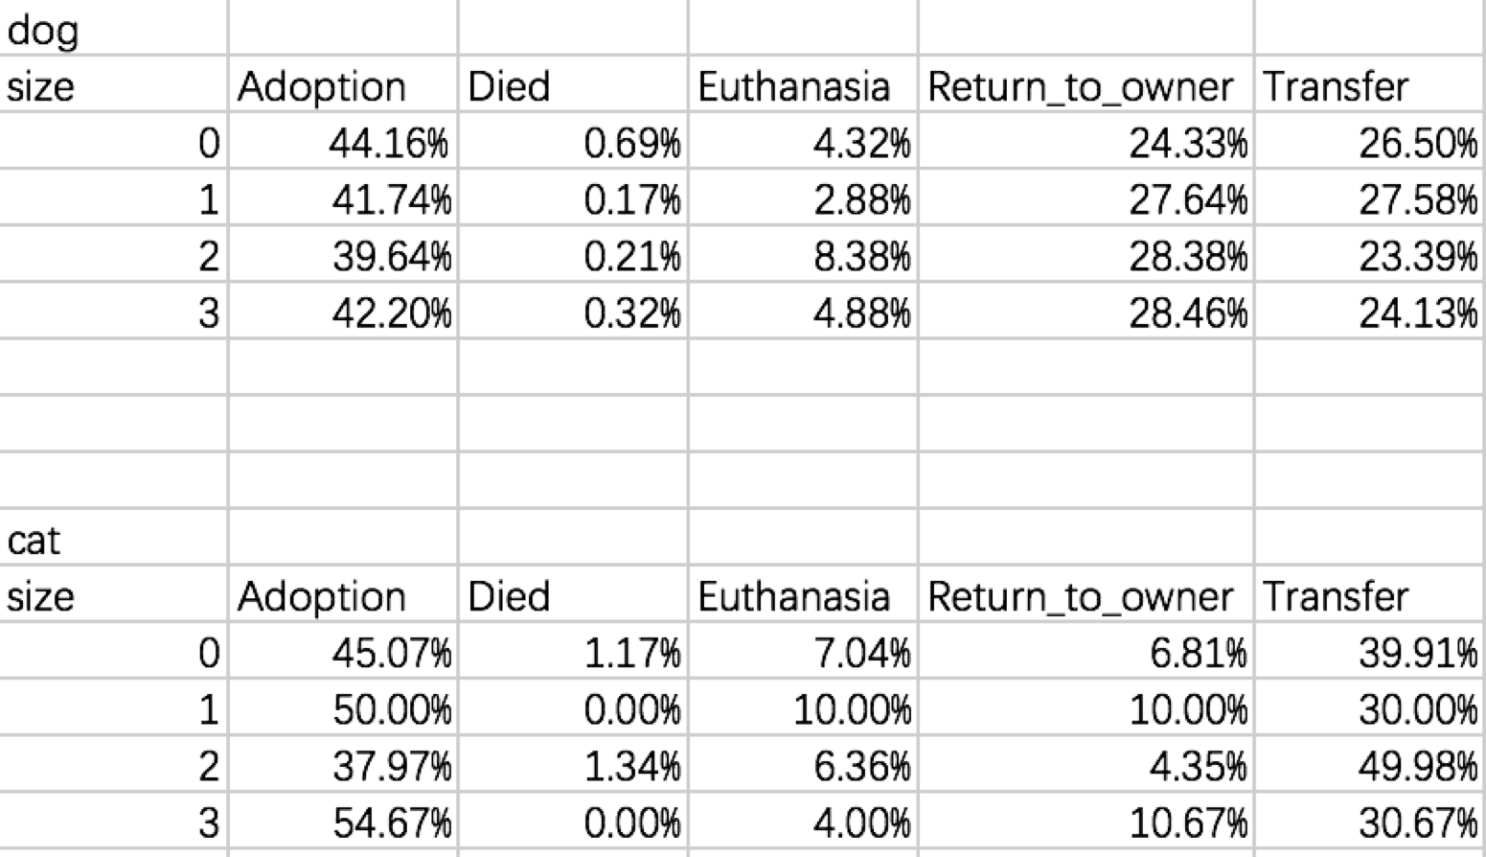

**3.3 Color**

**3.3.1 Color and Adoption**

create view adoption as select * from Final where OutcomeType = "Adoption";

-- cat

create view cc1 as select count(*) sum1,Color_mix,Color_1,Color_2,Color_ID from adoption where Animal_Type="Cat" group by Color_mix,Color_1,Color_2,Color_ID;

create view cc2 as select count(*) sum2,Color_ID from Final where Animal_Type="Cat" group by Color_ID;

select cc1.*,cc2.sum2 from cc1 join cc2 on cc1.Color_ID=cc2.Color_ID;

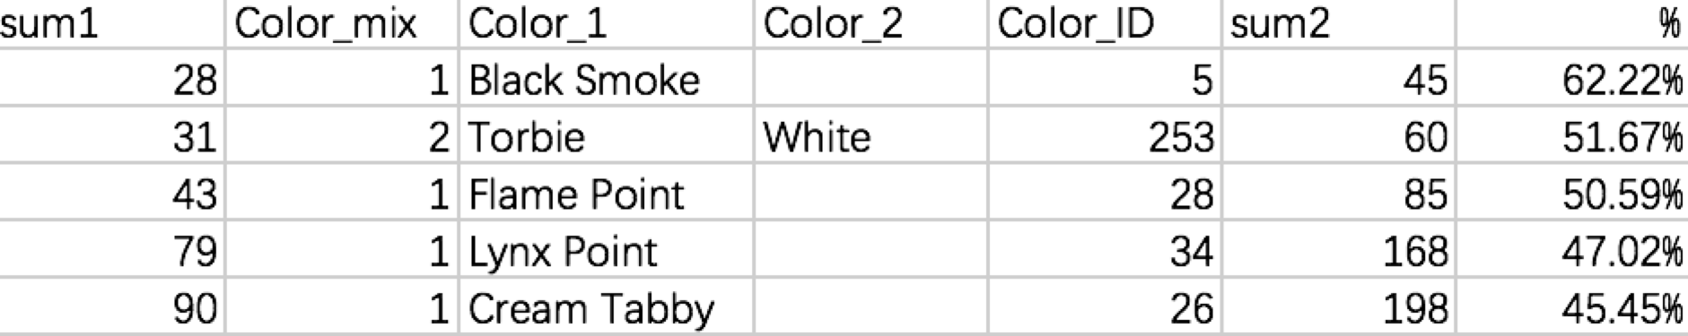

-- dog

create view dc1 as select count(*) sum1,Color_mix,Color_1,Color_2,Color_ID from adoption where Animal_Type="Dog" group by Color_mix,Color_1,Color_2,Color_ID;

create view dc2 as select count(*) sum2,Color_ID from Final where Animal_Type="Dog" group by Color_ID;

select dc1.*,dc2.sum2 from dc1 join dc2 on dc1.Color_ID=dc2.Color_ID;

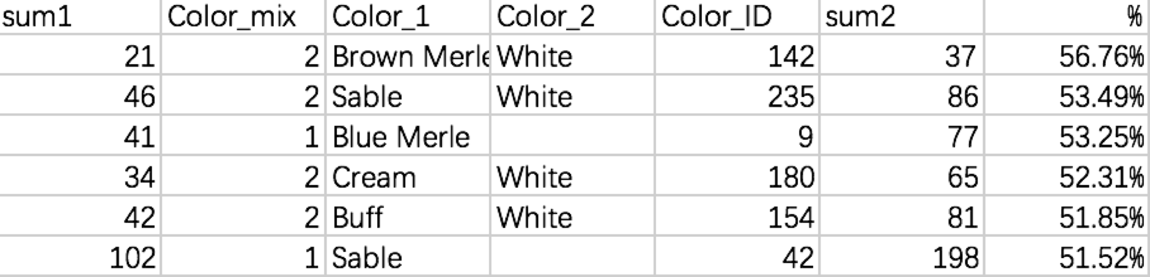

**3.3.2 color mix or not and adoption**

select count(*),Color_mix,Animal_Type from Final group by Color_mix,Animal_Type;

select count(*),Color_mix,Animal_Type from Final where OutcomeType = "Adoption"

group by Color_mix,Animal_Type;

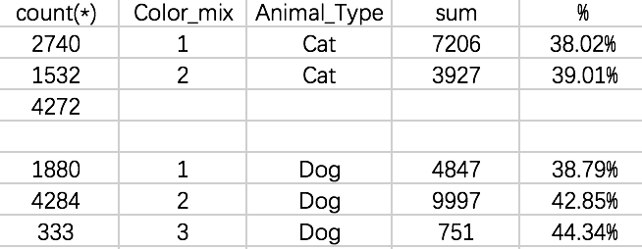

**3.4 Age**

select count(*),OutcomeType,Animal_Type from Final where age_month>=0 and age_month<=2 group by OutcomeType,Animal_Type;-- cat

select count(*),OutcomeType,Animal_Type from Final where age_month>2 and age_month<=12 group by OutcomeType,Animal_Type;-- cat

select count(*),OutcomeType,Animal_Type from Final where age_month>12 and age_month<=60 group by OutcomeType,Animal_Type;-- cat

select count(*),OutcomeType,Animal_Type from Final where age_month>60 and age_month<=120 group by OutcomeType,Animal_Type;-- cat

select count(*),OutcomeType,Animal_Type from Final where age_month>120

group by OutcomeType,Animal_Type;-- cat

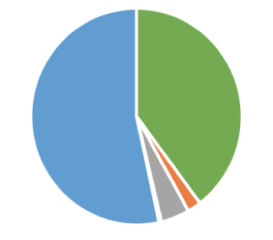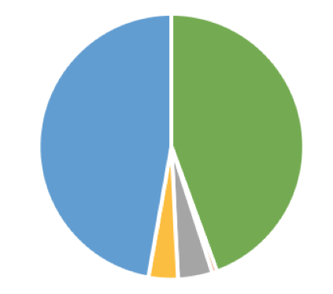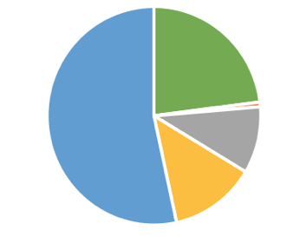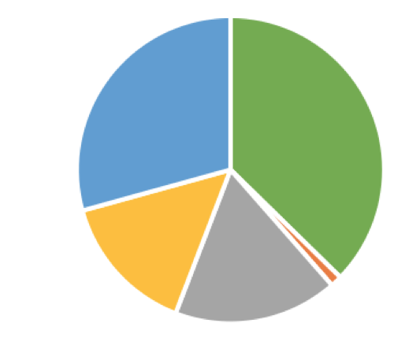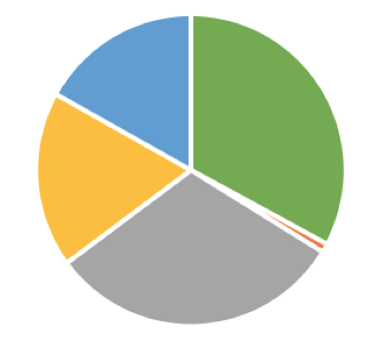

0-2 2-12 12-60 60-120 120+

-- dog

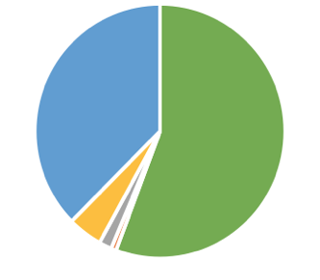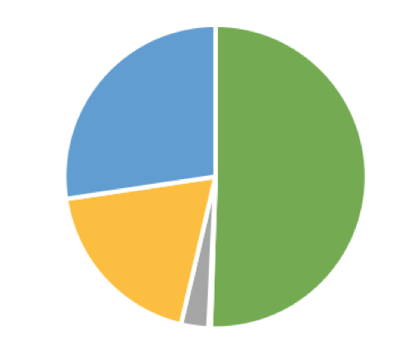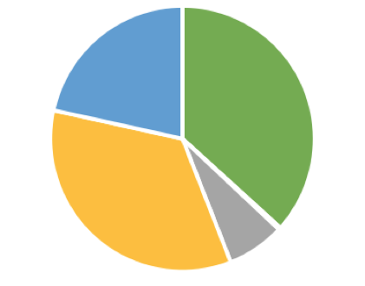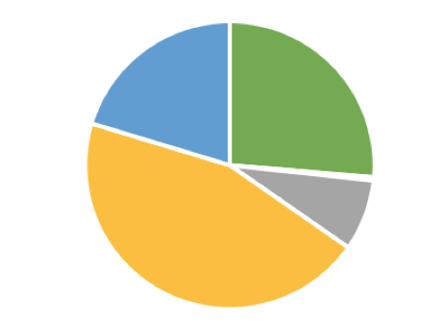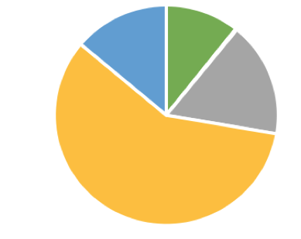

0-2 2-12 12-60 60-120 120+



** record without age data

select Animal_ID,age_month from Final where age_month is null; -- 18 rows

select Animal_ID,age_month from Final where age_month = 0; -- 22 rows

**3.5 Sex[3]**

select count(*),OutcomeType,SexuponOutcome from Final

group by OutcomeType,SexuponOutcome;

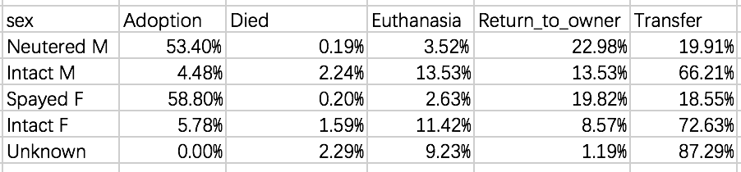

**3.6 Time**

**3.6.1 Outcome distribution in a year**

select count(*),outcome_month,outcome_date,OutcomeType

group by outcome_month,outcome_date,OutcomeType

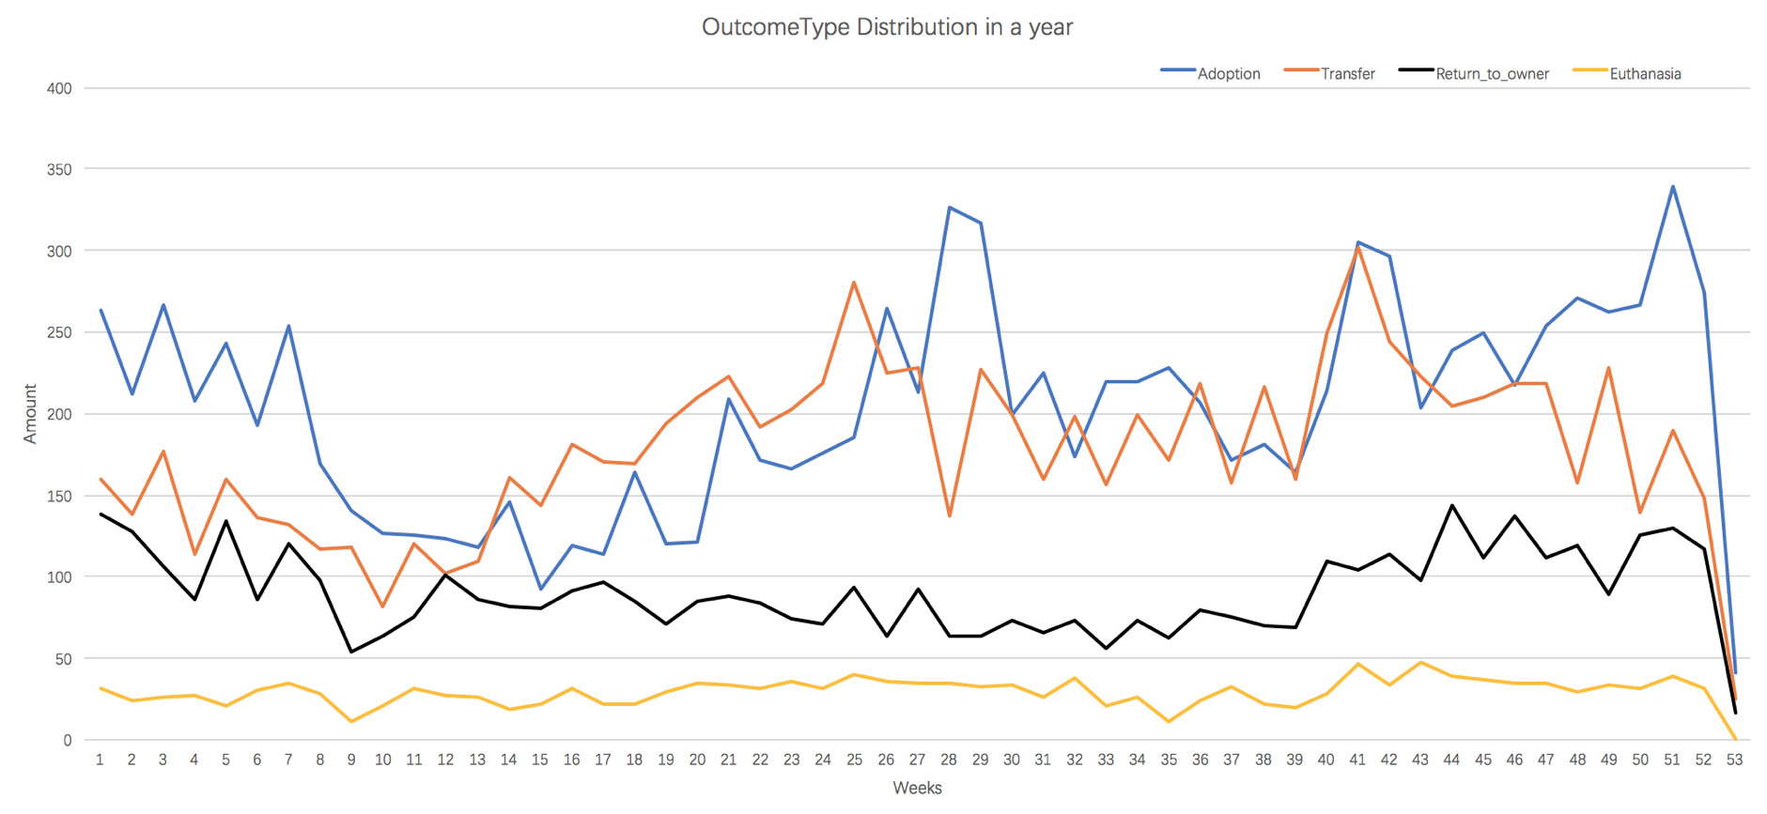

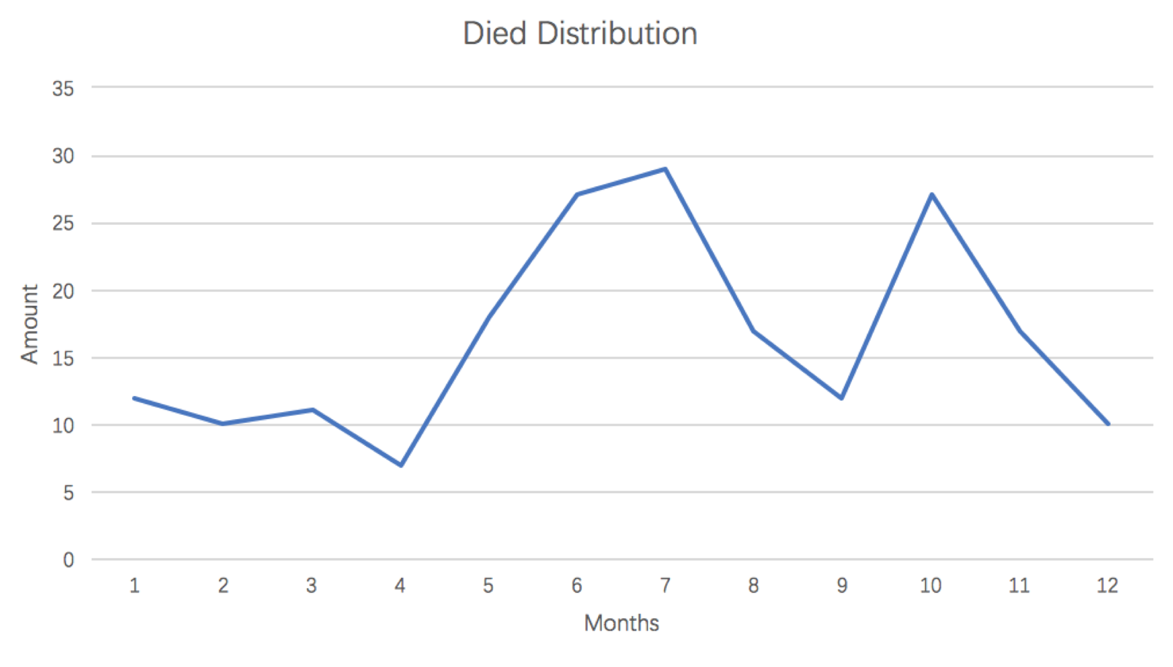

**3.6.1 Outcome and weekdays**

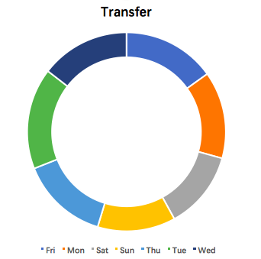 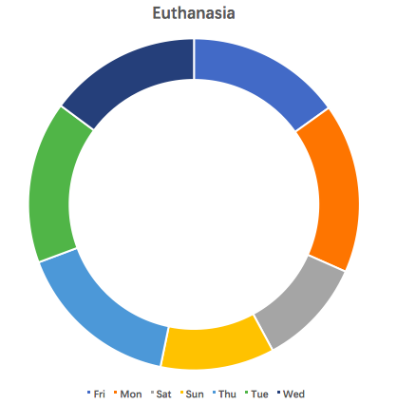

less in Saturday and Sunday less Saturday and Sunday, more in Monday

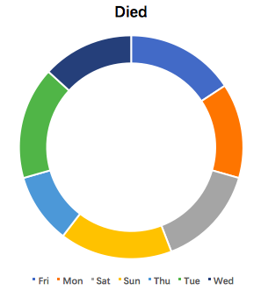 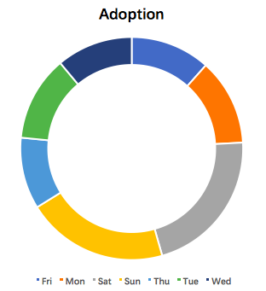 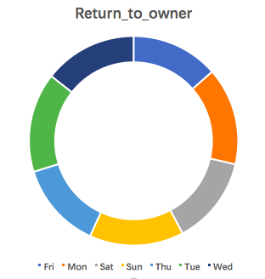

less in Thursday More in Saturday and Sunday the evenest outcome type

**3.7 Name**

select count(*) from Shelter where name<>'';

select count(*) as 'sum',OutcomeType from Shelter where name <>"" and age_month>1

group by OutcomeType;

There are 3540 animals in this shelter not older than 1 month. And 2671 of them have no name, the proportion of which is about 75.5%。

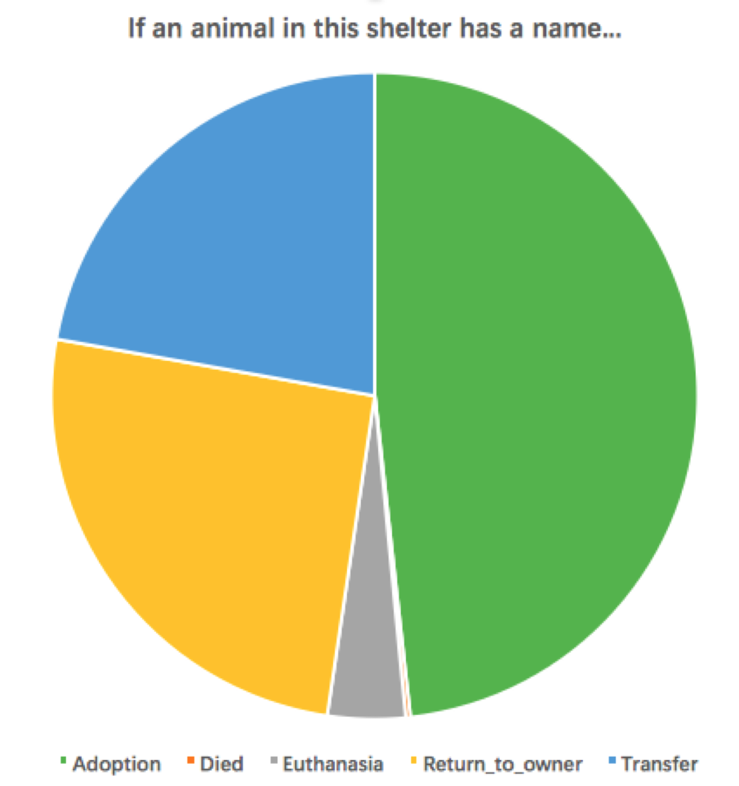 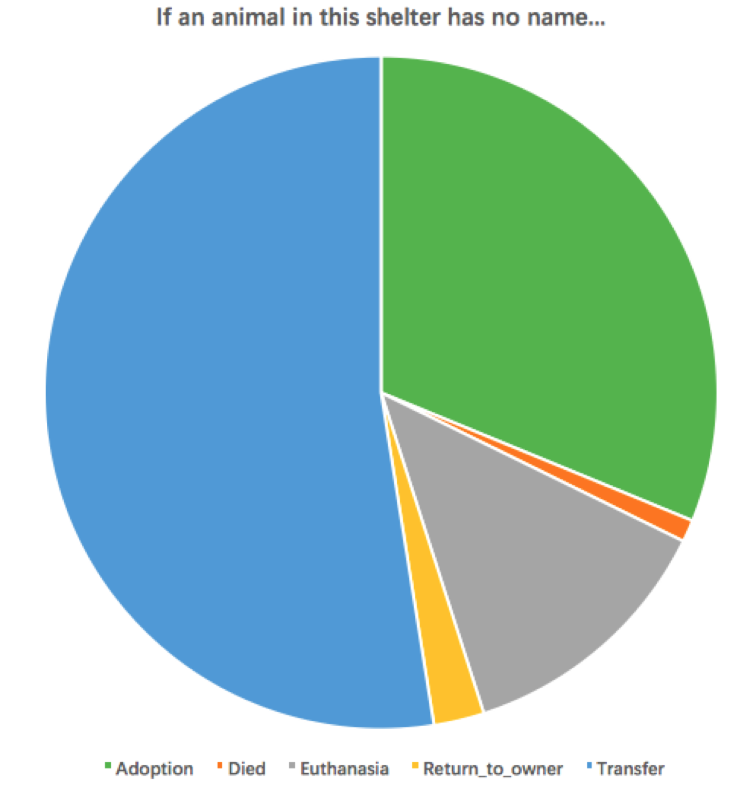

**4. Prediction**

**1.**

According to our tables, there are 3 variables for an animal that can influence the outcome results -- **Name, Breed_ID, Color_ID**, if we know nothing about their outcome age, time or sex. If an animal **has a name**, you have high possibility to get **adoption**, followed by return to owner and get transferred. **If not,** you’d probably get **transferred**, then followed by adoption.

If you are a **cat**, it’s easier for you to get **transferred**, followed by **adoption**, and your breed identity does change too much, because this shelter has too many of your kind.

If you are a **dog**, it’s much easier for you to **find a new owner**, especially if you are a popular breed like **Black Mouth Cur, Queensland Heeler, Australian Kelpie, German Shepherd, Labrador Retriever…** Then, you may also have high possibility to **go back home**, especially when you are a **Golden Retriever, Rottweiler, Labrador Retriever, German Shepherd, Siberian Husky…**

When considering about the **color**, adopters **don’t really care about dogs’ colors**, and the **mixed** color may have **a mild increase effect**. But if you are a cat, adopters may hope you are **black smoke or tobie mix white or flame point or lynx point**. And your color is mixed or not doesn’t really matter.

**2.**

If you view this prediction problem from the opposite side, which means should you be if you want certain outcome, we can also help you. Without considering if you have a name or not, we use breed and color information to give you this suggestion. We filter all the data counts more than 10.

If you want a **transfer**, hope you are a **cream Domestic Shorthair Mix.** The transfer rate is almost 92%. Only one of them is not transferred, he died. If you **don’t want a transfer, be a black and brown German Shepherd Mix**, it’s only 19%.

If you want to **go back to your owner**, hope you are **a yellow Labrador Retriever,** more than 84% of your kind go back to home. If you want to **stay here**, be **a Brown Tabby Domestic Shorthair Mix.** Well, they have more than 1400 of your kind in less than 3 years, I think they may have no time to care about you.

If you want to **test their euthanasia technology by yourself**, then be **a brown brindle Pit Bull Mix**. Actually, most kinds of these animals don’t get euthanasia.

If you want to **die**, be **a Domestic Shorthair Mix**, and have some **Brown Tabby, White, Black**. All these colors ensure your death, and actually your kind are the only kind who have more than 10 deaths in these years.

Finally, if you want to **get adopted**, hope you are a **white Maltese**, you have more than 82% possibility to achieve your dream. Or, if you **hate to have another owner**, then be a **tricolor Beagle**. The possibility is just 20%.

**5. Other novel discoveries**

**5.1 Business hour**

select count(*),outcome_hour from Final group by outcome_hour;

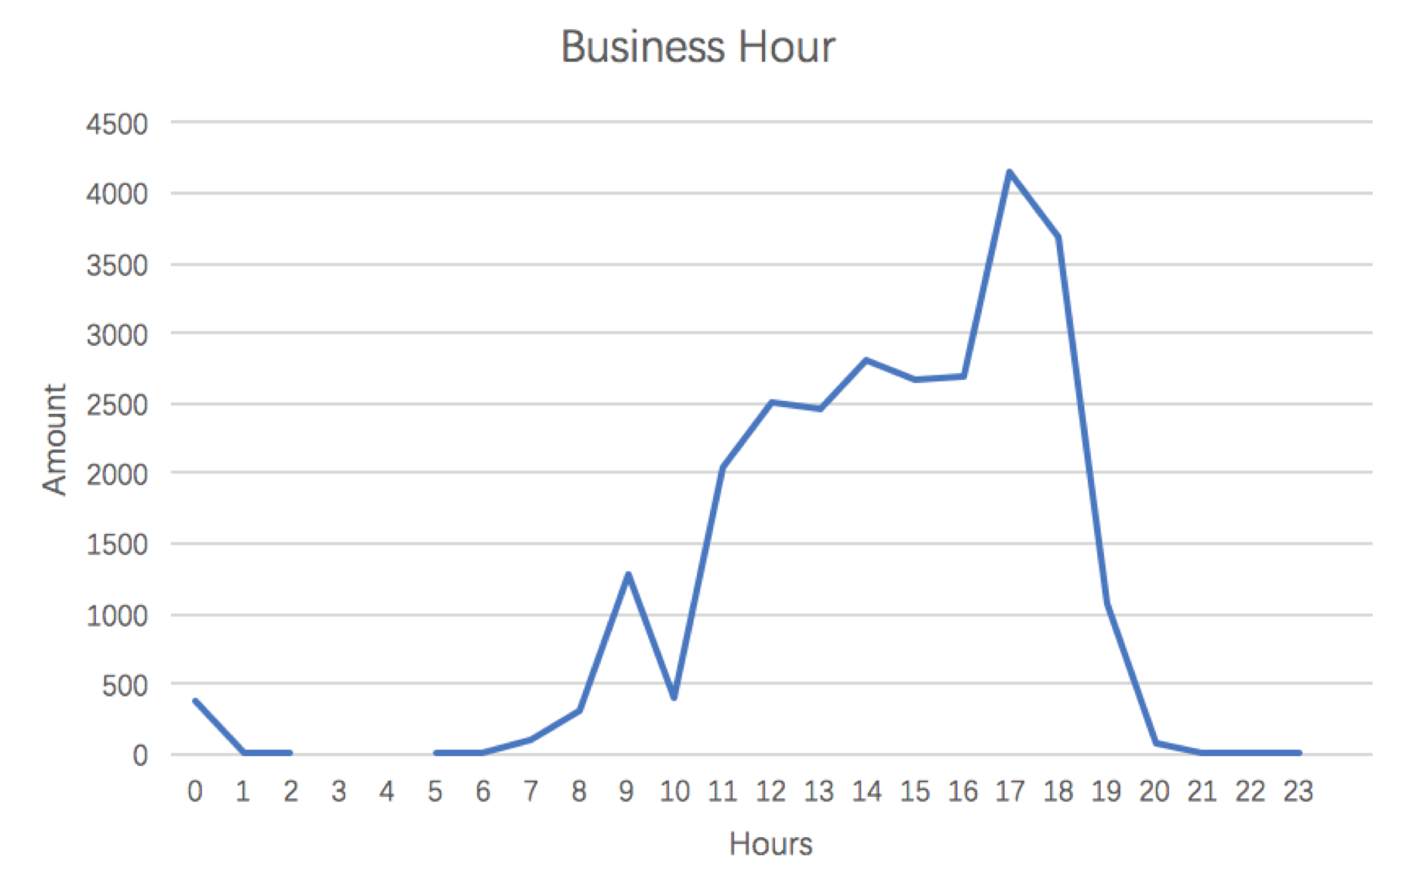

Monday:

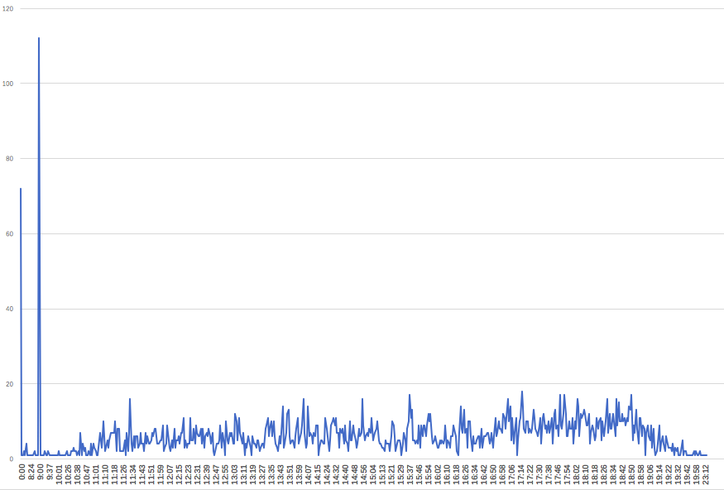 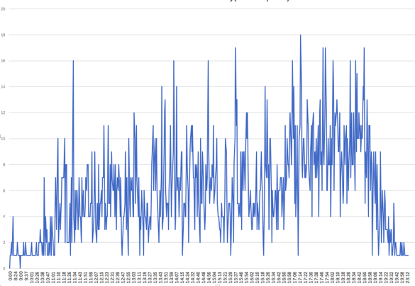

Tuesday:

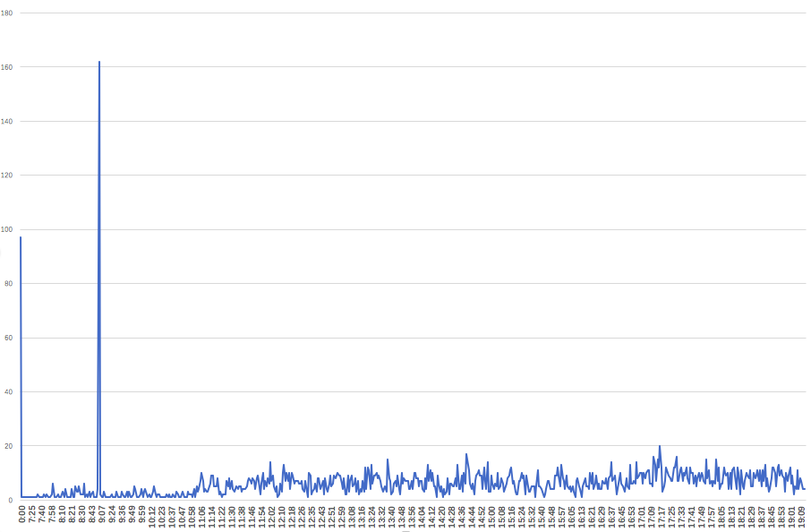 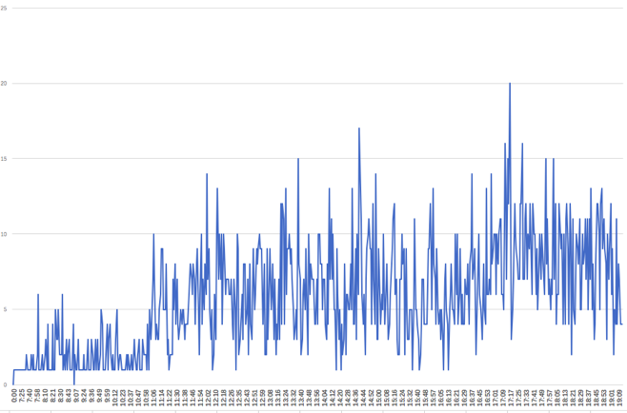

Wednesday:

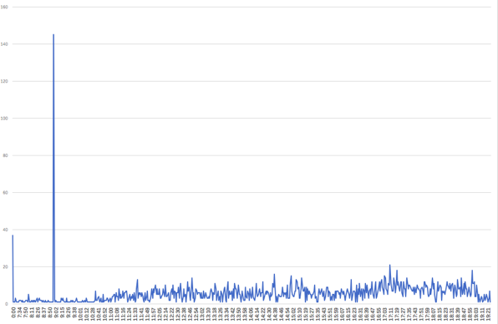 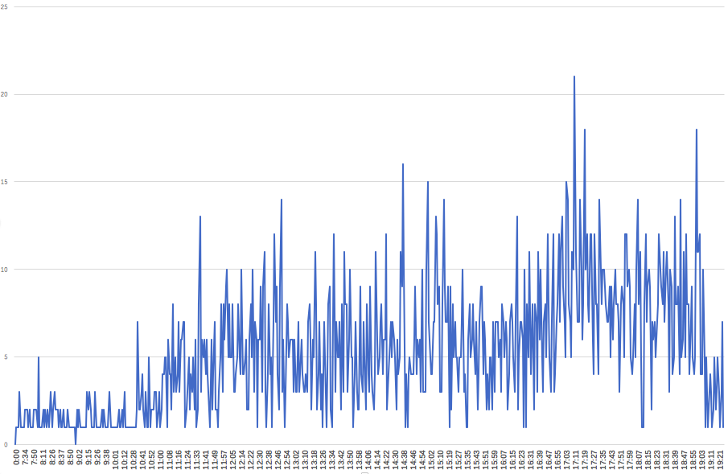

Thursday:

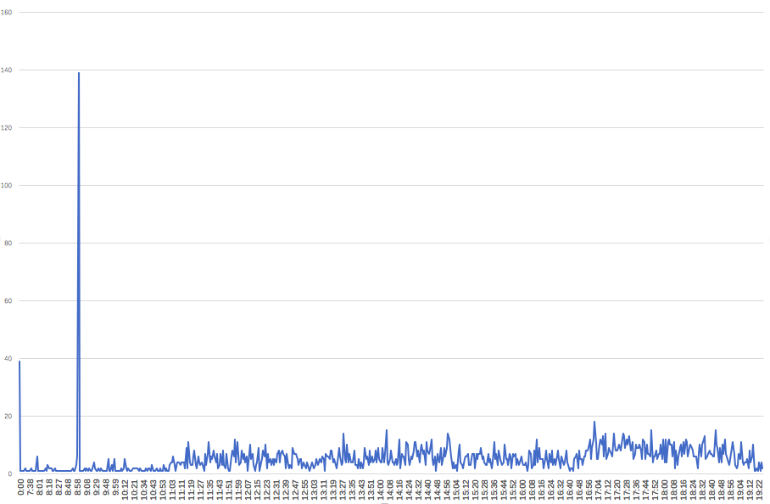 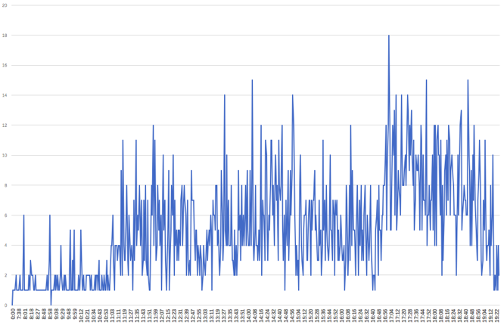

Friday:

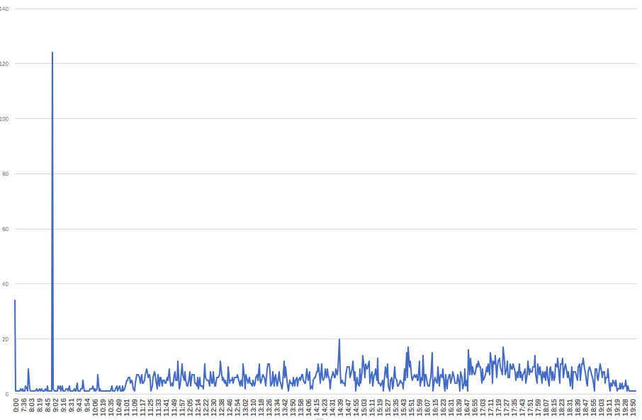 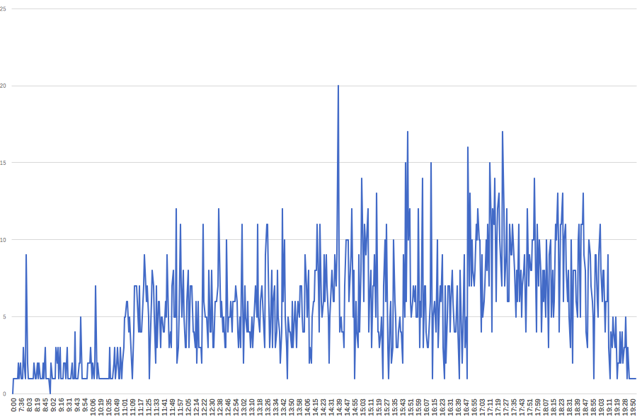

Saturday:

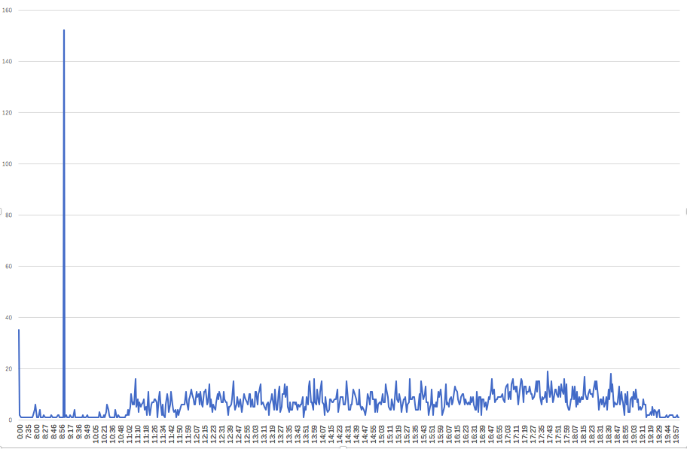 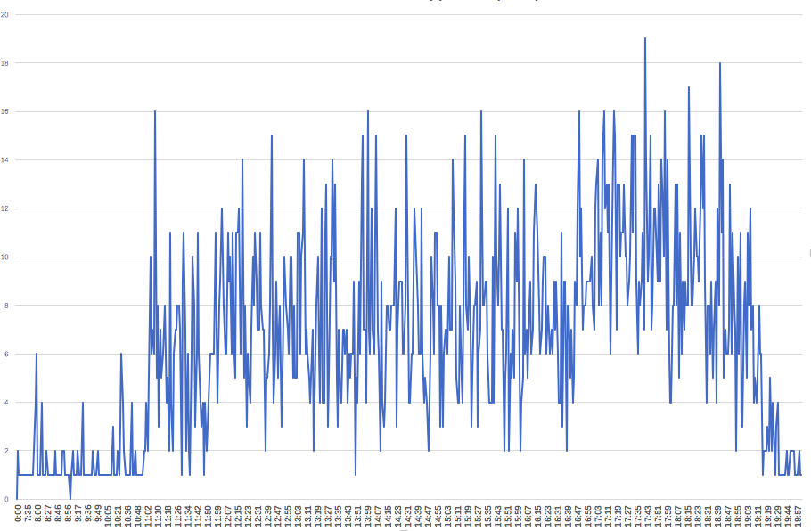

Sunday:

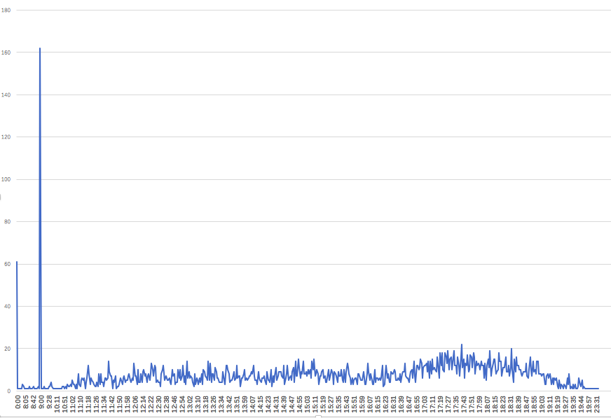 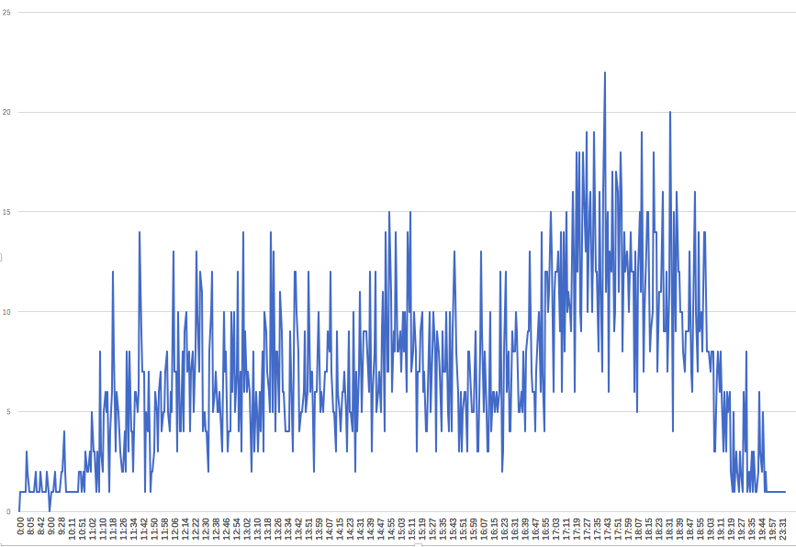

According to these business hour data, we exclude some outliers and assume that the business time in each weekday as below:

Mon: 8:00 am- 8:00 pm

Tues: 7:30 am- 7:30 pm

Wed: 7:30 am- 7:30 pm

Thu: 7:30 am- 7:30 pm

Fri: 7:30 am- 7:30 pm

Sat: 7:30 am- 8:00 pm

Sun: 8:00 am- 8:00 pm

**5.2 Work peaks**

select count(*),OutcomeType from Final where outcome_hour = 0 group by OutcomeType;

SELECT OutcomeType,Parent_1,Parent_2,Breed_Mix,Size,Animal_type,age_month FROM animal_shelter.Shelter where Outcome_hour=9 and Outcome_minute=0;

create view temp11 as (SELECT concat(year,'-',month) as m FROM animal_shelter.weekday where hour=9 and minute=0);

SELECT m,count(m) FROM animal_shelter.temp11 group by m ;

**5.2.1 Midnight (0:00am)**

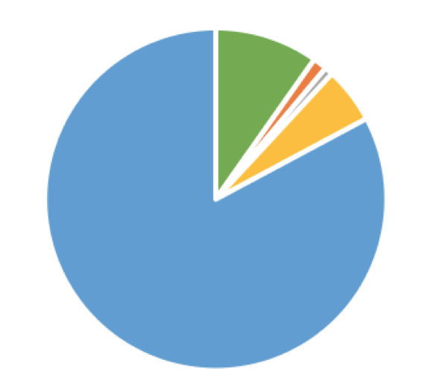



How the practice of recording “0:00am” changed?

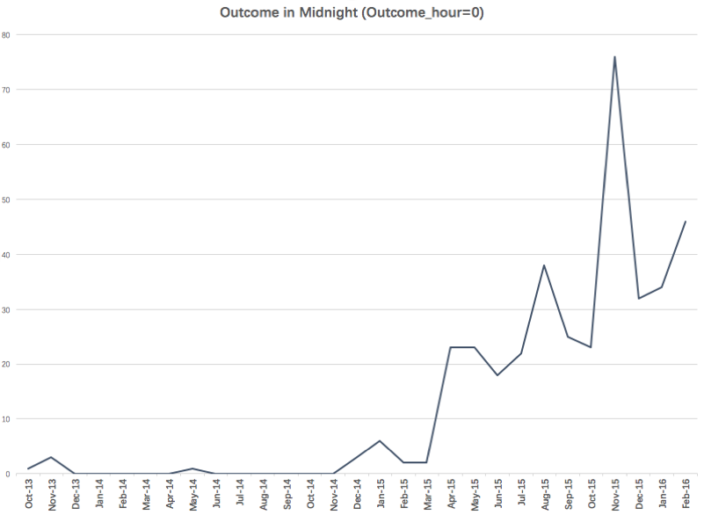

We make the hypothesis that recording the missing data on “0:00am” is individual practices at first, but later it becomes the universal practices.

**5.2.2 9.am**

There are 996 rows in 9:00 am, all of them are **transfer** outcomes. And the transferred animals are all **cats**, mainly **Domestic Longhair, Domestic Medium Hair, Domestic Shorthair and Siamese cats**.

How the practice of recording “9:00am” changed?

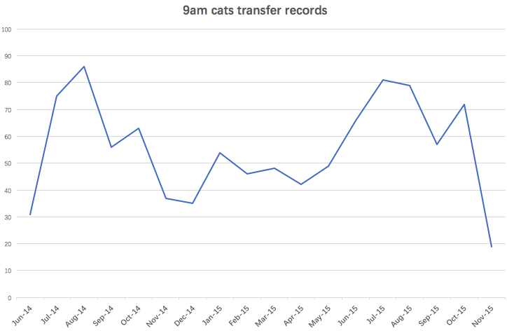

We assume that this animal began a cooperation with another cat shelter in June,2014 and ended in November,2015. That shelter come to pick the cats every morning.

**5.3 Birthday**

We used the data of animals whose age below 6 months, because we assume that their birthdays can be calculated more accurately.

#create a table contains their age as ‘day’

create table age_date as(

select Outcome_year,Outcome_month,Outcome_date,age_month,Animal_Type,30*age_month as age_days FROM Shelter where age_month<6);

alter table age_date modify age_days int(8);

SELECT birthday,count(*) FROM animal_shelter.Birthday

group by birthday ORDER BY birthday;

**def** get_birth(url):  
 birthyear=[]  
 birthmonth=[]  
 birthdate=[]  
 birth=[]  
 f1 = open(url, **'rU'**)  
 f1_list = csv.reader(f1)  
 **for** content **in** f1_list:  
 outcome= datetime.datetime(int(content[0]),int(content[1]), int(content[2]))  
 birthday = outcome - datetime.timedelta(days=int(content[5]))  
 m = re.match(**r'(\d+)-(\d+)-(\d+)'**, str(birthday))  
 birth.append(m.group())  
 birthyear.append(m.group(1))  
 birthmonth.append(m.group(2))  
 birthdate.append(m.group(3))  
  
 df={**'Birth'**:birth,**'Birthyear'**:birthyear,**'Birthmonth'**:birthmonth,**'Birthdate'**:birthdate}  
 out=pd.DataFrame(df)  
 out.to_csv(**'/Users/andyzhao/Desktop/Database Management/Project/temp.csv'**)

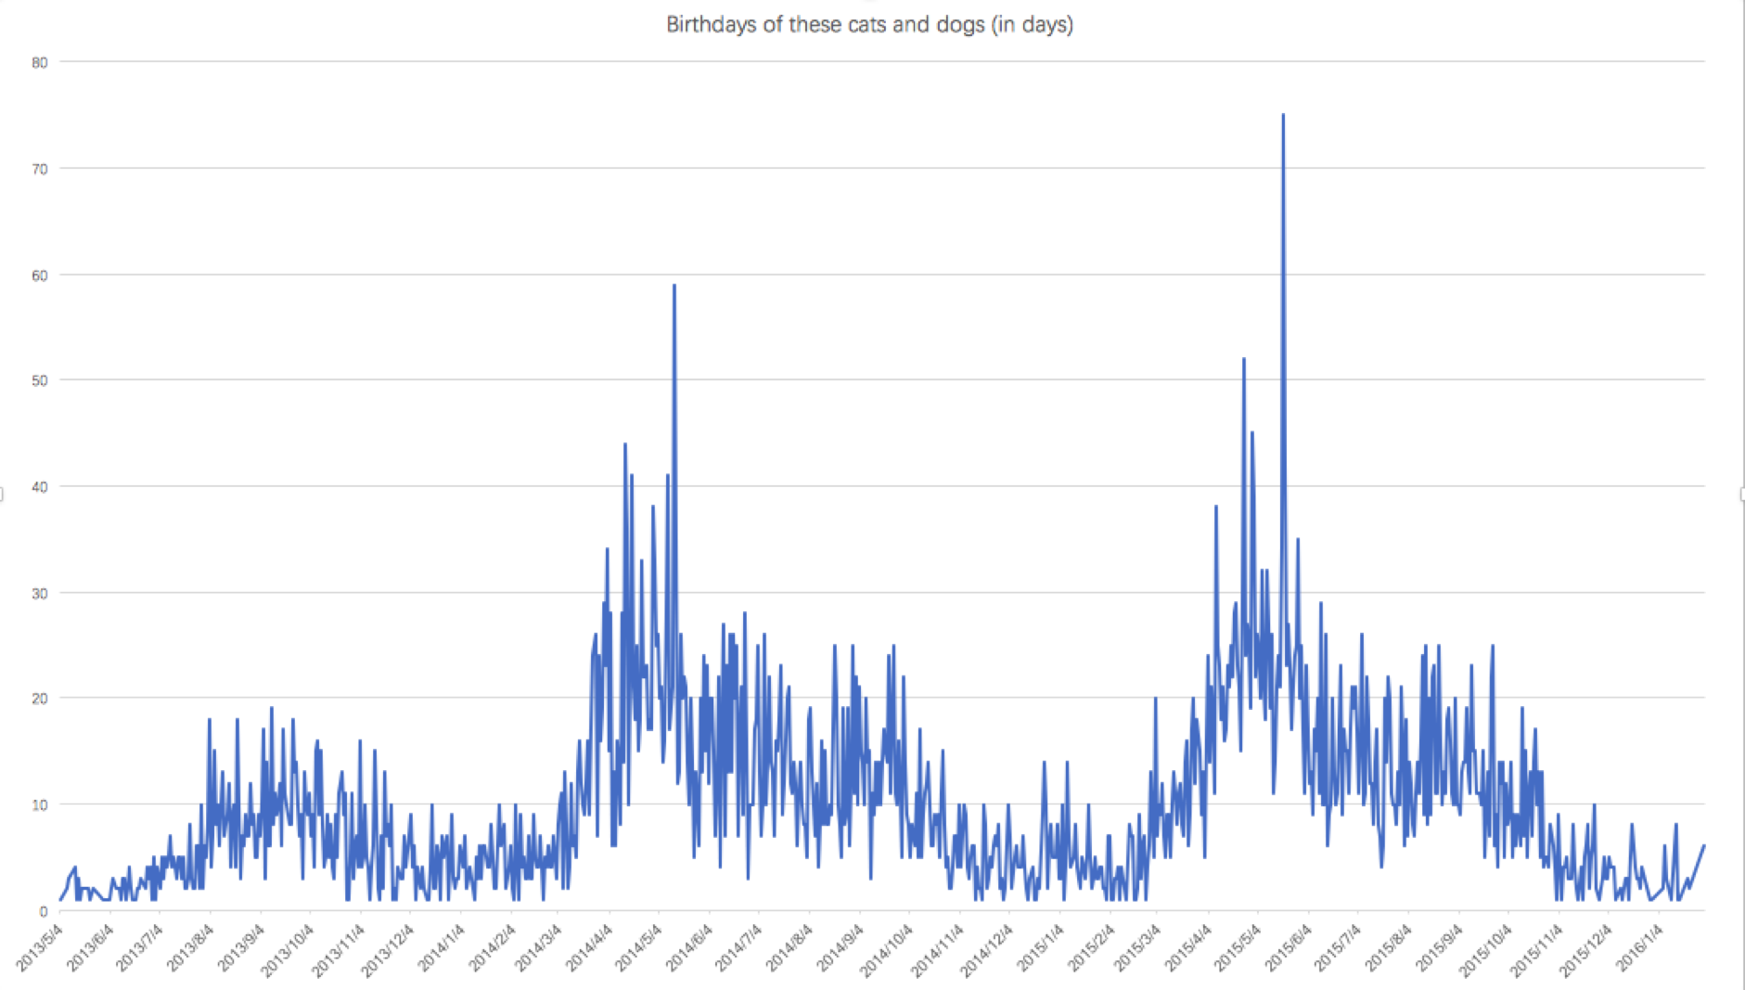

SELECT month,count(*) FROM birthmonth group by month ORDER BY month;

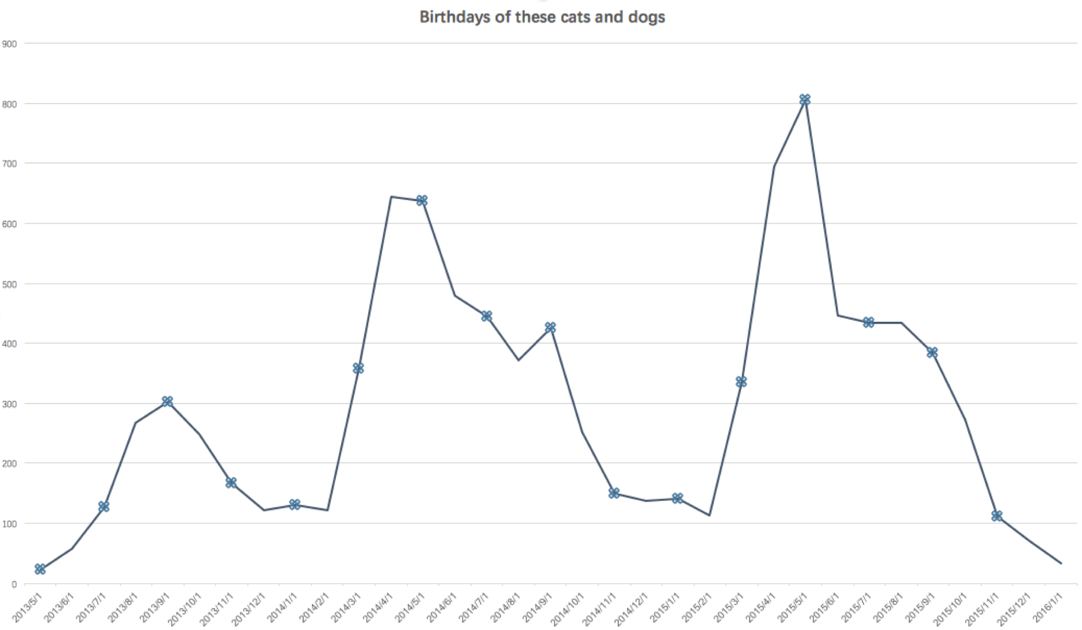

It’s easy to notice birth peaks in summer and birth slumps in winter.

-- cat

SELECT month,count(*) FROM birthmonth where type='Cat'

group by month ORDER BY month;

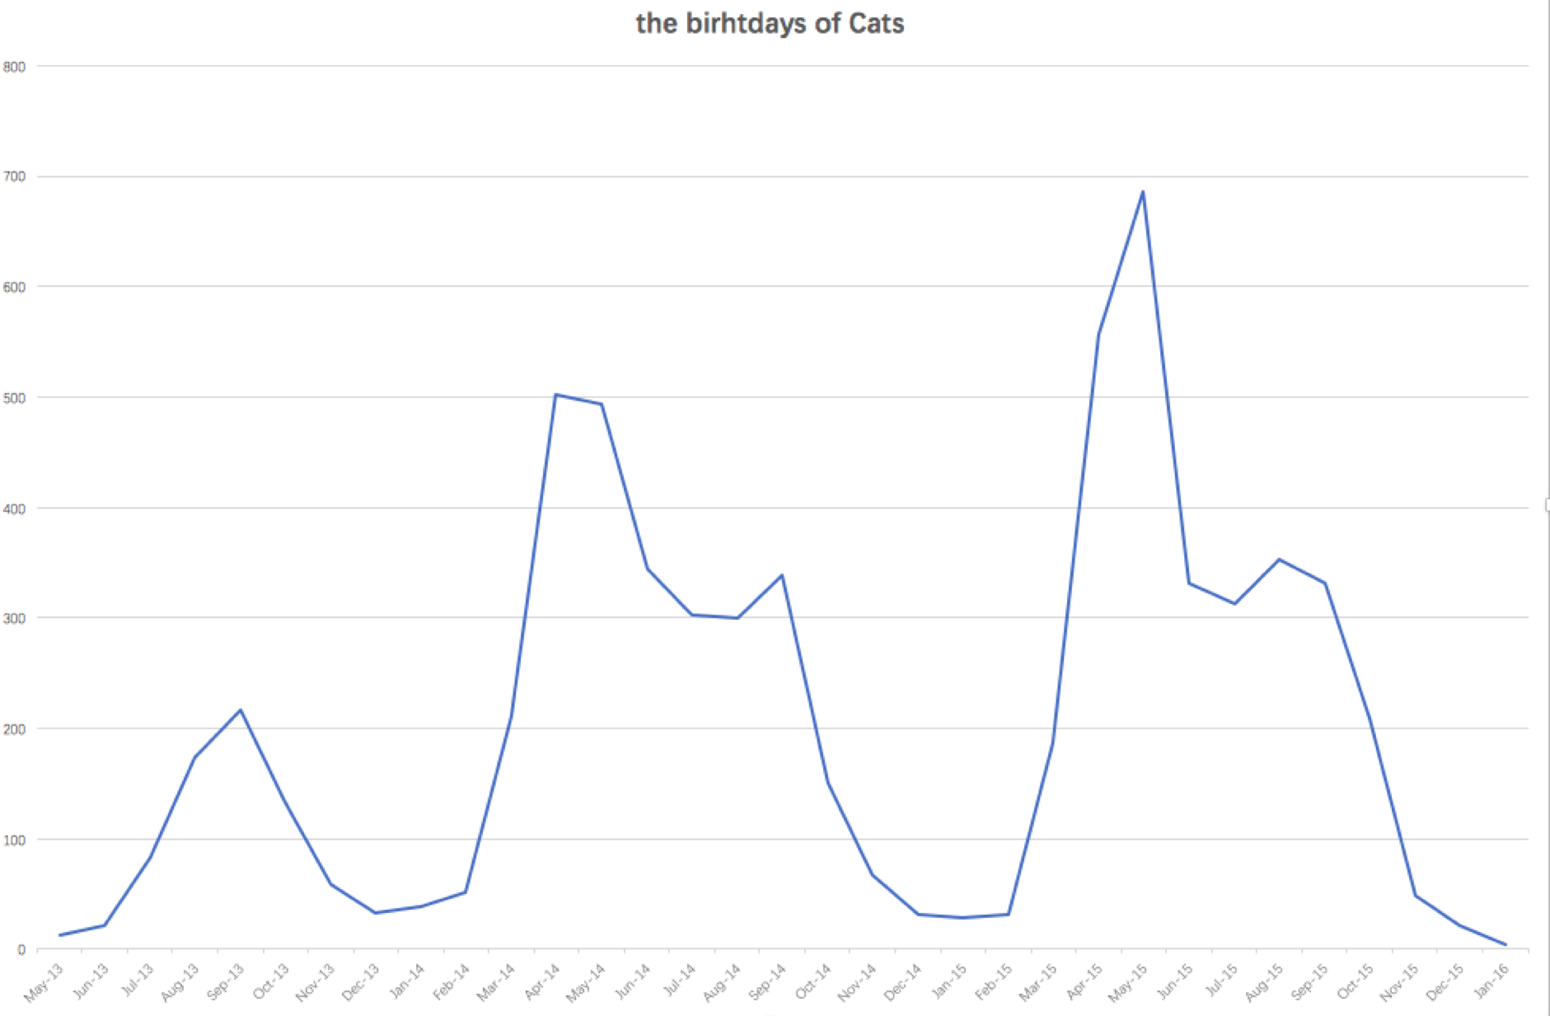

The cats have really obvious birth peaks and slumps.

-- dog

SELECT month,count(*) FROM birthmonth where type='Dog'

group by month ORDER BY month;

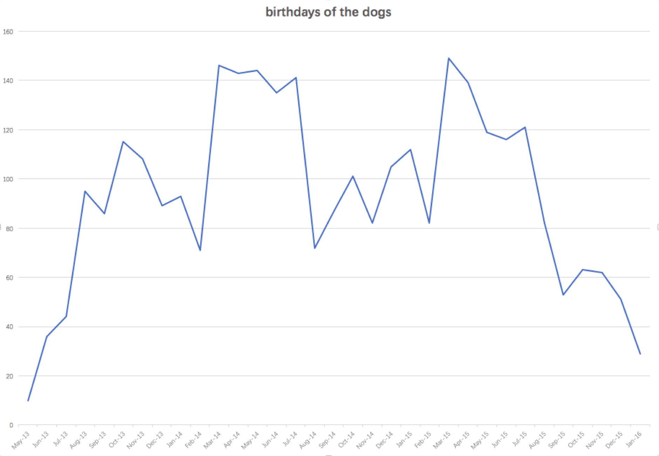

Comparing to cats, the changes of birth cycles are not dramatic.

**5.4 Shelter capacity for babys**

We used the data of animals whose age is not more than 2 months, because we assume that all of them are born in this shelter. And baby animals need special, different care and facilities, which have different capacity limitation with others.

create table baby as(

select Outcome_year,Outcome_month,Outcome_date,age_month,Animal_Type,30*age_month as age_days FROM Shelter where age_month<=2);

**def** get_capacity(url):  
 f1 = open(url, **'rU'**)  
 datecount={}  
 f1_list = csv.reader(f1)  
 **for** content **in** f1_list:  
 **print** content  
 dateList = []  
 **try**:  
 outcome = datetime.date(int(content[0]), int(content[1]), int(content[2]))  
 birth=datetime.date(int(content[7]), int(content[6]), int(content[5]))  
 range=int((outcome-birth).days)  
 **while** range != 0:  
 date = outcome - datetime.timedelta(days=range)  
 range = range - 1  
 dateList.append(str(date))  
 **except**:  
 **print** content  
 **for** each **in** dateList:  
 **if** each **not in** datecount.keys():  
 datecount[each]=1  
 **else**:  
 datecount[each]=datecount[each]+1  
 writer = csv.writer(open(**'/Users/andyzhao/Desktop/Database Management/Project/count.csv'**, **'wb'**))  
 **for** key, value **in** datecount.items():  
 writer.writerow([key, value])

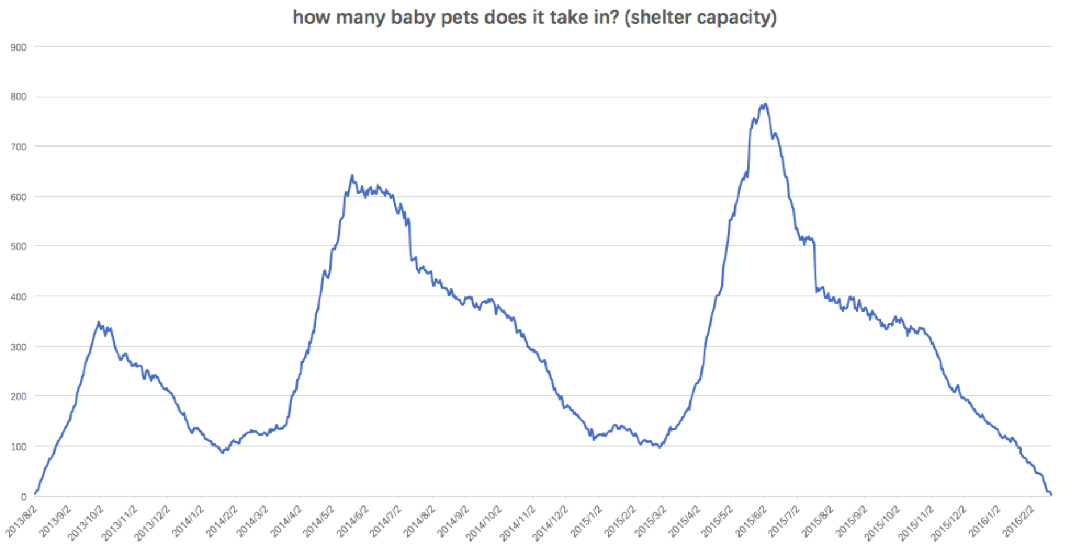

The change of containment is consistent with the birth cycles. And the baby capacity of this shelter is about 700.

**5.5 Main color**

** Filter all the rows whose count below 100, and choose the informative breeds to create their dominant colors, which don’t represent the color size in those pets.

SELECT Parent_1,Parent_2,Color_1,Color_2,count(Parent_1) FROM breed_color

group by Parent_1,Parent_2,Color_1,Color_2 order by count(Parent_1) desc

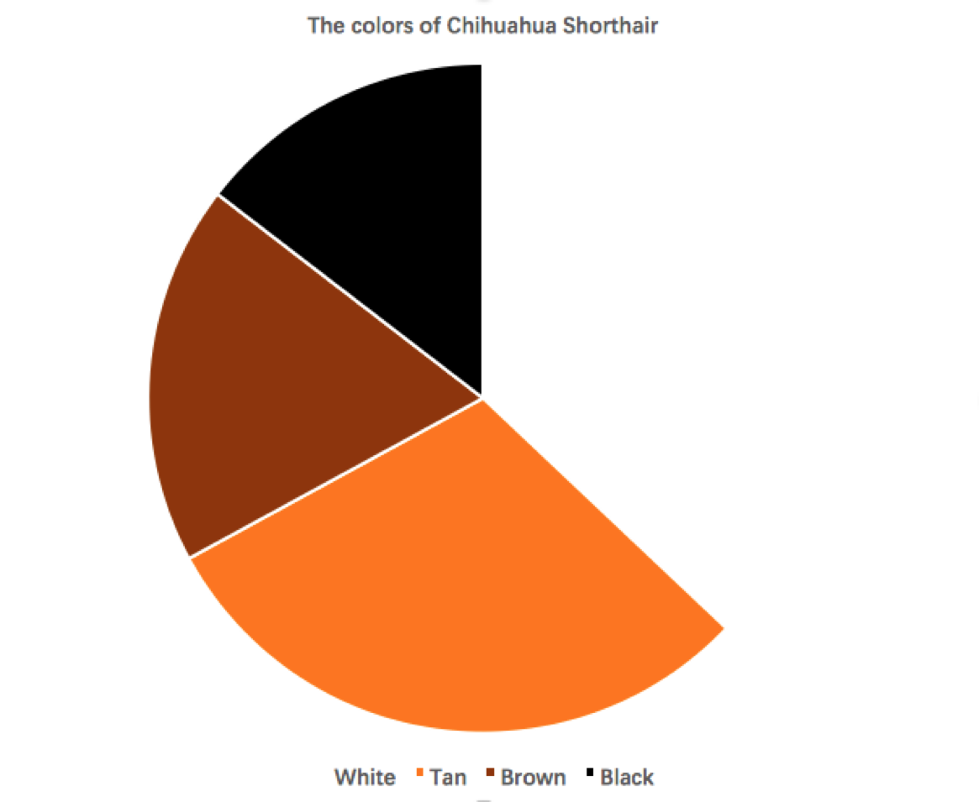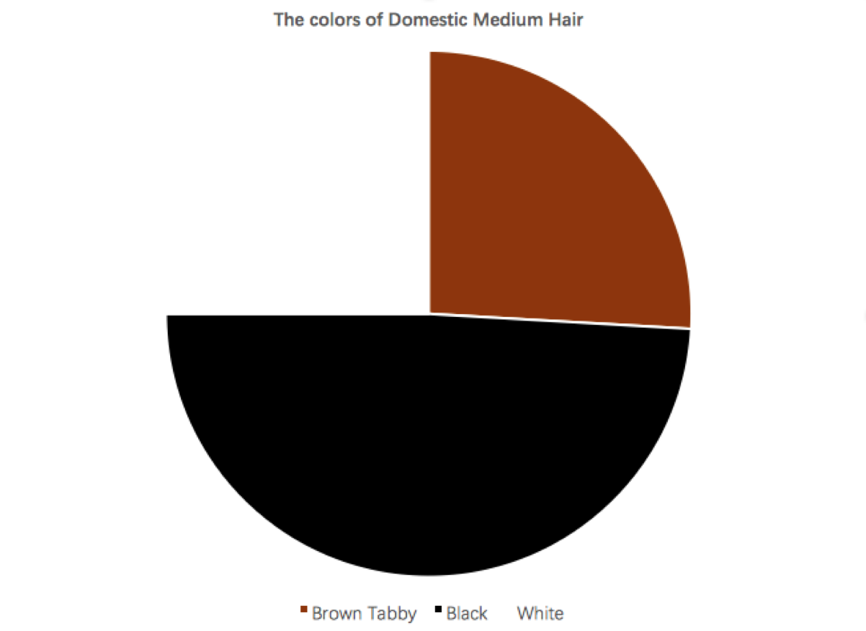

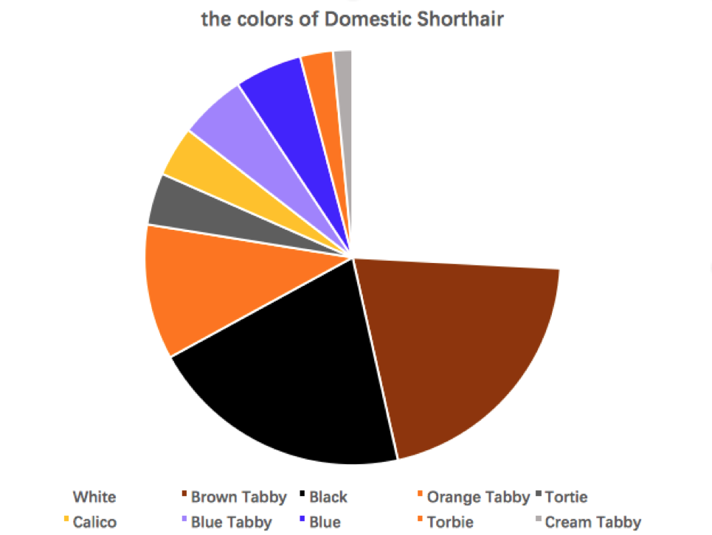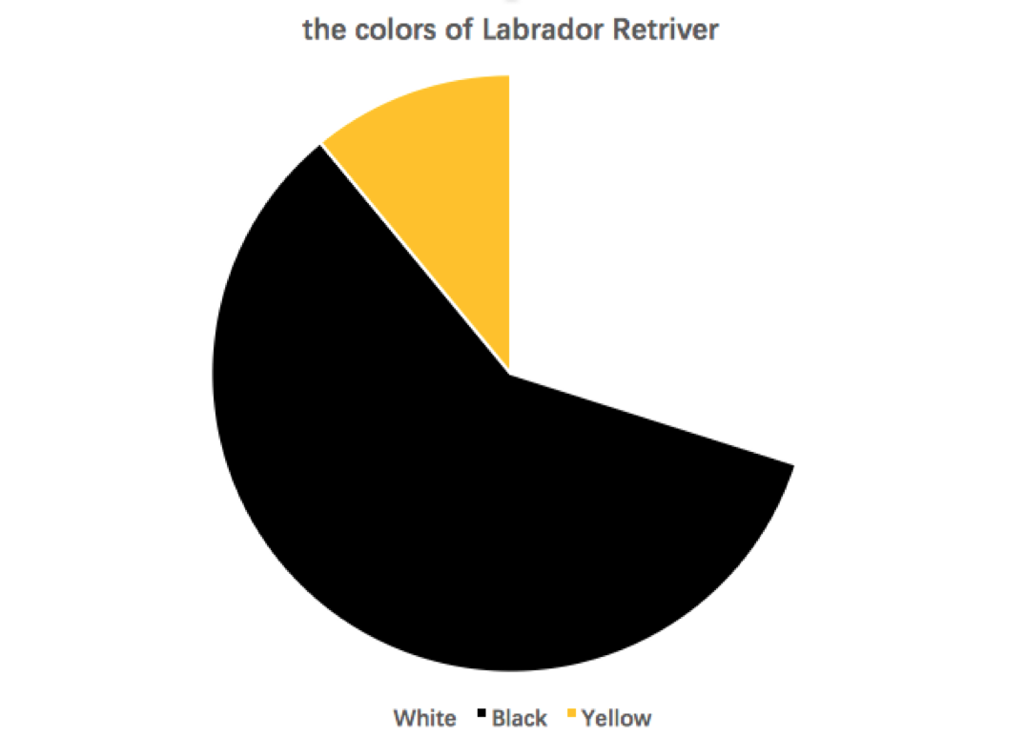

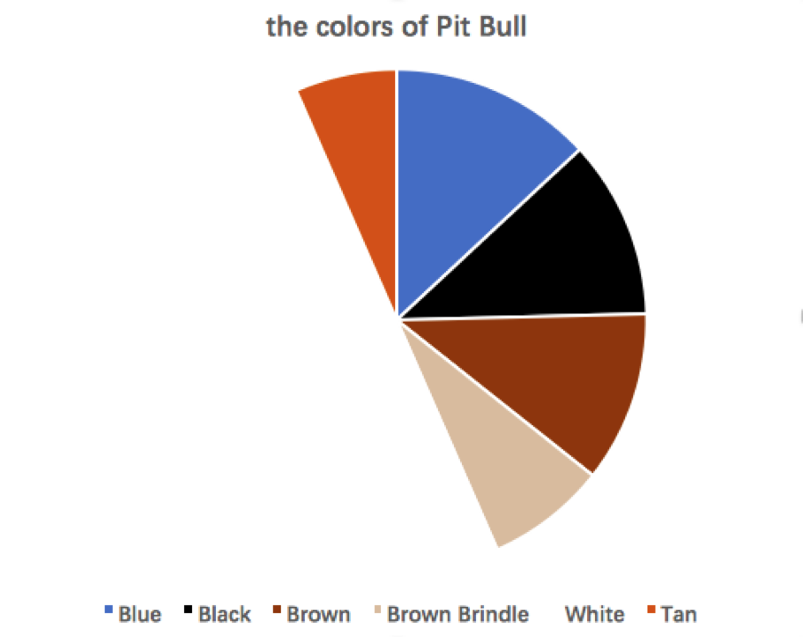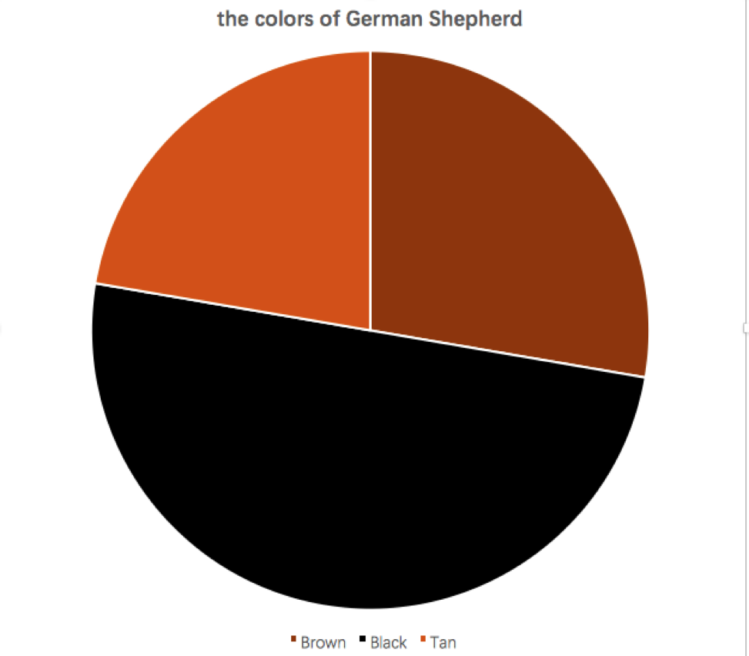

** only one main color

Most of Miniature Poodles are white.

Most of Siamese are Lynx Point.

**6. References**

[1] American Curl Cat Breed Information, Pictures, Characteristics & Facts. (n.d.). Retrieved December 03, 2017, from http://cattime.com/cat-breeds/american-curl-cats#/slide/1

[2] Dog Breed Database & Information - Bil-Jac (n.d.). Retrieved December 03, 2017, from <https://www.bil-jac.com/dog-breed-library.php>

[3] Shelter Animal Outcomes | Kaggle (n.d.). Retrieved December 03, 2017, from <https://www.kaggle.com/c/shelter-animal-outcomes>